What is a Neural Network?
“Artificial” neural networks are inspired by the organic brain, translated to the computer. It’s not a perfect comparison, but there are neurons, activations, and lots of interconnectivity, even if the underlying processes are quite different.
A single neuron by itself is relatively useless, but, when combined with hundreds or thousands
(or many more) of other neurons, the interconnectivity produces relationships and results that
frequently outperform any other machine learning methods.
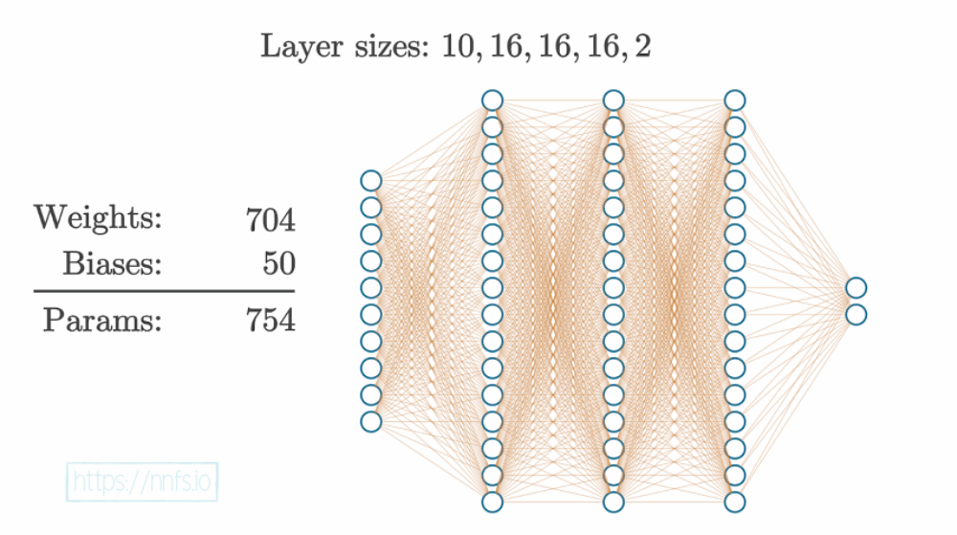
It might seem rather complicated when you look at it this way. Neural networks are considered
to be “black boxes” in that we often have no idea why they reach the conclusions they do. We do
understand how they do this, though.
Dense layers, the most common layers, consist of interconnected neurons. In a dense layer, each
neuron of a given layer is connected to every neuron of the next layer, which means that its output
value becomes an input for the next neurons. Each connection between neurons has a weight
associated with it, which is a trainable factor of how much of this input to use, and this weight
gets multiplied by the input value. Once all of the inputs·weights flow into our neuron, they are
summed, and a bias, another trainable parameter, is added. The purpose of the bias is to offset the
output positively or negatively, which can further help us map more real-world types of dynamic
data.
Biases and weights are both tunable parameters, and both will impact the neurons’ outputs, but
they do so in different ways. Since weights are multiplied, they will only change the magnitude or
even completely flip the sign from positive to negative, or vice versa. Output = weight·input+bias
is not unlike the equation for a line y = mx+b .
We can visualize this with: Graph of a single-input neuron’s output with a weight of 1, bias of 0 and input x .
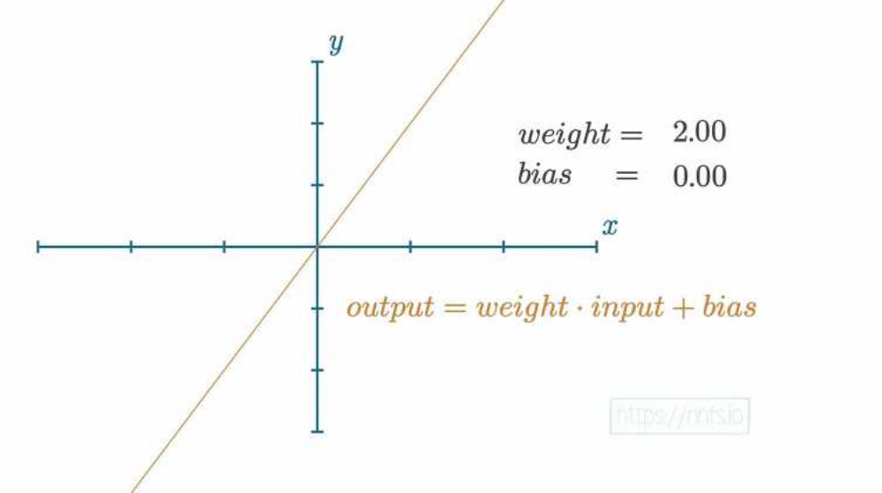

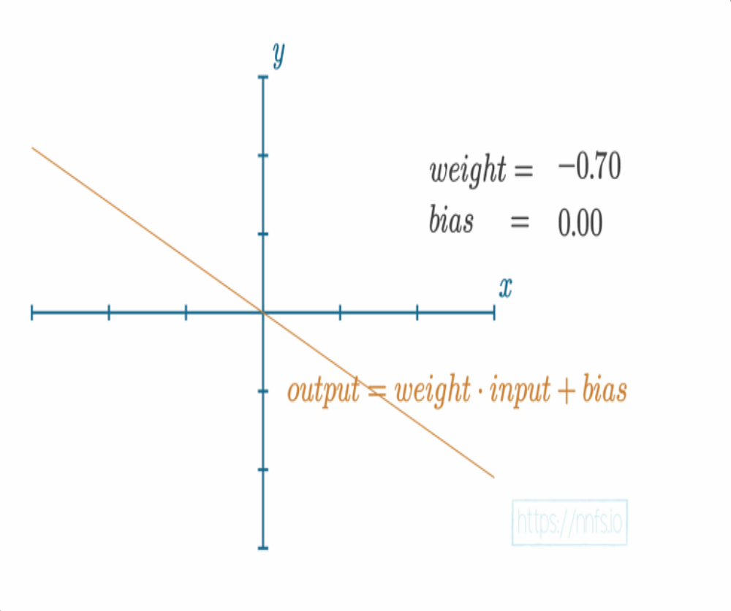
As we increase the value of the weight, the slope will get steeper. If we decrease the weight, the slope will decrease. If we negate the weight, the slope turns to negative:
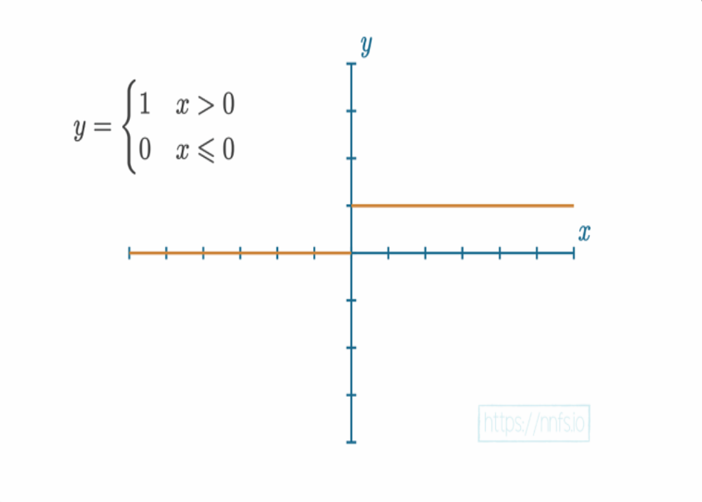For a step function, if the neuron’s output value, which is calculated by sum(inputs · weights)
+ bias , is greater than 0, the neuron fires (so it would output a 1). Otherwise, it does not fire
and would pass along a 0. The formula for a single neuron might look something like: output = sum (inputs * weights) + bias
We then usually apply an activation function to this output, noted by activation() : output = activation(output)
While you can use a step function for your activation function, we tend to use something slightly more advanced. Neural networks of today tend to use more informative activation functions
(rather than a step function), such as the Rectified Linear (ReLU) activation function,Each neuron’s output could be a part of the ending output layer, as well as the input to another layer of neurons. While the full function of a neural network can
get very large, let’s start with a simple example with 2 hidden layers of 4 neurons each.

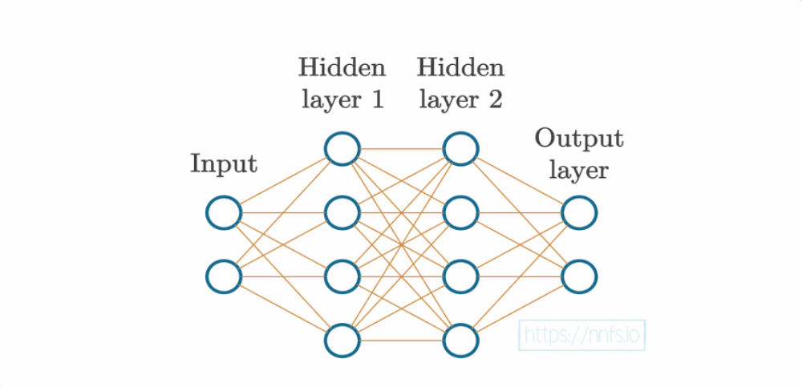
Along with these 2 hidden layers, there are also two more layers here — the input and output layers. The input layer represents your actual input data, for example, pixel values from an image
or data from a temperature sensor. While this data can be “raw” in the exact form it was collected, you will typically preprocess your data through functions like normalization and scaling , and your input needs to be in numeric form. Concepts like scaling and normalization will be covered later in this book. However, it is common to preprocess data while retaining its features and having the values in similar ranges between 0 and 1 or -1 and 1. To achieve this, you will use either or both scaling and normalization functions. The output layer is whatever the neural
network returns. With classification, where we aim to predict the class of the input, the output layer often has as many neurons as the training dataset has classes, but can also have a single
output neuron for binary (two classes) classification. We’ll discuss this type of model later and, for now, focus on a classifier that uses a separate output neuron per each class. For example, if
our goal is to classify a collection of pictures as a “dog” or “cat,” then there are two classes in total. This means our output layer will consist of two neurons; one neuron associated with “dog”
and the other with “cat.” You could also have just a single output neuron that is “dog” or “not dog.”

Such that classify :-
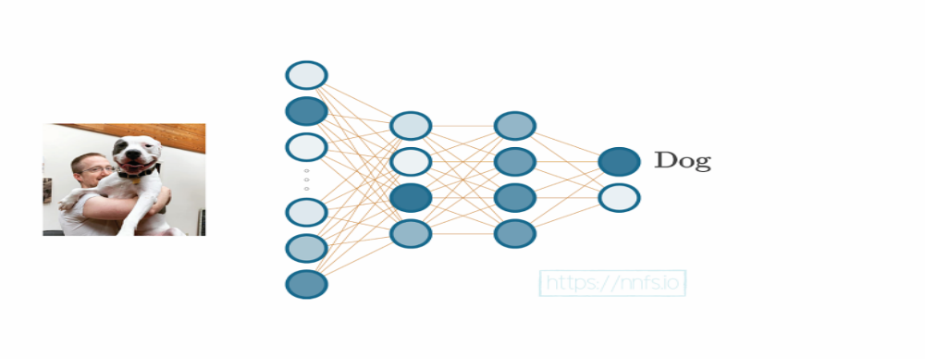
*--------------------------------------------------------------------------------------*
In order for neural networks to create the intended output when used to an input of an as-yet-unseen example, their weights and biases (the parameters) must be adjusted. During algorithm training for supervised machine learning, we provide the algorithm with examples of inputs and their correspondingly desired results. Overfitting is a significant problem with this idea; it occurs when the algorithm does not genuinely "understand" anything; it just learns to suit the training data. input-output relationships that are hidden. The training data is essentially "memorised" by the network.

As a result, we frequently train a model using "in-sample" data before testing it using "out-of-sample" data.
certify an algorithm (or a neural network model in our case). There are designated percentages to divide the data between the two databases. For
. You would instantly take 10,000 samples from a dataset of 100,000 samples of data and labels and set them aside as your "out-of-sample" or "validation" data.

The remaining 90.000 "training" or "in-sample" data will then be used to train your model, and the remaining 10,000 "out-of-sample" data will be used to validate it. The objective is for the model to make equally accurate predictions on the withheld out-of-sample validation data as it does on the training data.
This process of learning to suit the material rather than memorization is known as generalisation. The concept is to use numerous examples of data to "train" (slowly modify weights and biases) a neural network.
The neural network is then given out-of-sample data that it has never seen before in the hopes that it would be able to forecast effectively on these data as well.
Now that you know a little bit about neural networks, or at the very least what the

What our goal is, and how do we intend to achieve it? We compute the training set for these neural networks.

Using algorithms to determine the error (also known as loss), and making an effort to progressively weights and biases so that the network steadily improves over several iterations becomes less incorrect All neural networks aim to generalise, which means that the network can observe a lot of samples of new data, and output the values we hope to achieve. Use of neural networks for purposes beyond simple categorisation. They are capable clustering, which divides unstructured data into groups, regression, which forecasts a scalar, singular value, and
numerous other duties For neural networks, classification is simply one of many typical tasks.

End of Chapter ----------------- summaries by eman shehta

